Computer Hardware, Windows Administration & Troubleshooting

Theory + Practical Examination

Section A – Theory

Q1. Answer Questions.
- Differentiate between SMPS and UPS.
SMPS UPS
- Switch mode power spplay uninterruptible power splay
- AC to DC covert provide power back
- No battery has a battery
- Installed inside installed outside
- What is the purpose of Device Manager
ANS:device manager main purpose is view to manager update.

- Explain the use of DNS Cache.
- What is the function of a Device Driver?
ANS:operating system to communication with and control a hardware device.
- What is the difference between HDD and SSD?
ANS:HHD SSD
- Hard disk drive simple state drive
- Slower high
- Chepar expansive
- Movig parts allowed no moving parts
- Explain the use of Task Manager.
ANS:system performance and running application is used to task manager.
- What is the purpose of Battery Report?
ANS:battery report genrat

Section B – Command & Troubleshooting

Q2. Write the appropriate command for the following.
Task | Command
Find computer name | ____hostname_____
Find current user | _whoami________
Display IP address | __ipconfig_______
View active network connections | ______ping ___
Open Device Manager | Devmgmt.msc_________

Q3. Scenario-Based Questions

Scenario 1
A printer is connected but not printing.
- Mention any 3 troubleshooting steps.
ANS: chek power supply on.
Chek the Drivers installed .
USB cable attached.

Scenario 2
A webcam is not detected.
- Which Windows tool will you use first and why?

Section C – Practical Examination

Q4. Perform Tasks
- Find the Computer Name using CMD.
ANS:hostname
- Find the Current Logged-in User.
ANS:whoami
- Display detailed Network Information.
ANS:netsh wlan show profile
- Generate a Battery Report.
ANS:powercfg /betteryreport
- Open Device Manager using Run Command.
ANS:devmgmt.msc
- Find CPU Name using CMD.
ANS:wmic cpu get name
- Find System Serial Number.
ANS:systeminfo
- Display Installed Drivers.
ANS:driverquery

Section D – Advanced Challenge

Q5. Complete Tasks

Task A
Using CMD, find:
- CPU Name
ANS:wmic cpu get name
- RAM Capacity
ANS:wmic memorychip get capacity
- BIOS Version
ANS:msinfo32

Task B
Using CMD, identify:
- Active Network Connections
Ping
- Saved Wi-Fi Profiles
ANS:netsh wlan show profile name=”wi-fi name” key=clear

Task C
Create a hidden folder named Exam and then make it visible again.
Commands:
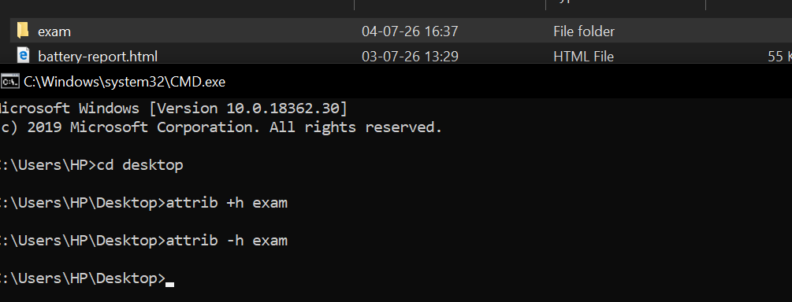sattrib -h Exam

